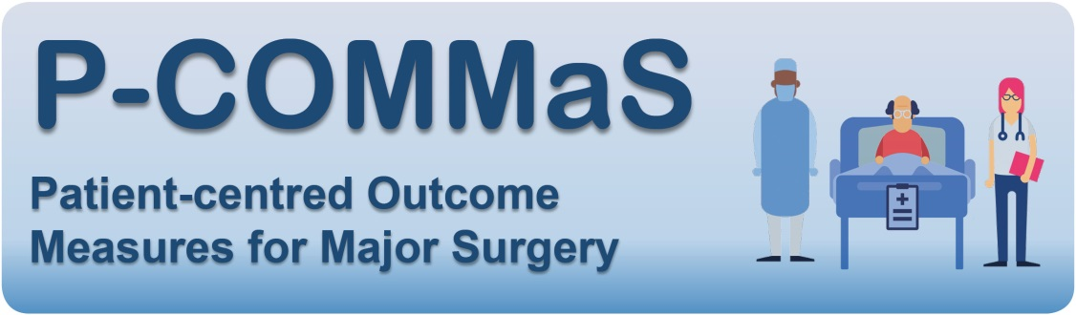

PARTICIPANT INFORMATION SHEET
(Patients & Carers)
Invitation and summary
We are inviting patients who have had major surgery (i.e. any big operation) and their carers to take part in a study aiming to get to the heart of what really matters to patients after a major operation. How do patients decide whether their operation was a success? How should health professionals researching new surgical innovations evaluate the results?

We’re inviting you to tell us your views about what matters most to patients after a big operation in a brief survey which will take around 10 minutes to complete. If you’d like to expand on your views at greater length, you’ll also be invited to take part in a telephone interview to tell us more about your experiences.

WHAT’S INVOLVED?

Why are we doing this research?
This study aims to define patient-centred outcomes for major surgery. We want to know what matters most to patients having a big operation. People have operations for lots of reasons, but how do they decide whether it’s been a success?
At the moment, researchers report a whole range of different measures (‘outcomes’) to evaluate whether an operation (surgery) has been successful. For example, research on hip replacement operations might look at how long patients stay in hospital afterwards, or how many suffer complications, such as a blood clot or ‘deep vein thrombosis’. Few studies, however, look at outcomes beyond the short to medium term. And we still don’t fully understand which outcomes matter most to the person at the centre of it all – the patient.
We’ve reviewed the research over the past 10 years to find out which outcomes are currently being measured– so we have a good idea of how we measure surgical outcomes at the moment. But we don’t know whether we are measuring the outcomes that actually matter most to patients. This study aims to address that deficit by asking patients, carers and clinicians their views about outcomes after surgery, in order to develop patient-centred outcome measures for research trials that truly reflect what matters most to patients who have major surgery.

What will it involve?
- A short survey (approximately 10 minutes), where you will be asked to rate the importance of various possible outcomes after an operation, and suggest any others you think are important. The survey will also ask for some basic demographic information (such as your age, gender and ethnicity.) You can complete the survey online or on paper as you prefer. (If you choose to complete a paper survey, we will give you a reply-paid envelope to post your completed paper survey to us).
- At the end of the survey, you will be asked if you would be willing to take part in a short telephone interview (approx. 20-30 minutes) to tell us in your own words about your own experiences of major surgery – whether as a patient, or caring for someone who had a big operation. The interview will explore aspects such as how you judge the ‘success’ of an operation, how patients decide whether to have an operation or not, and which outcomes after surgery you consider most important to know.
If you agree, we will contact you to arrange a convenient time for the interview. The interviewer will have no involvement in the care of any patients who participate in the study. You can therefore rest assured that the views you express will not affect your or your loved ones’ future care in any way.
The interviewer will take notes and make an audio recording, using a digital voice recorder. Recorded interviews will be transcribed (written up) and the tape will then be wiped clean. All information will be anonymised and treated as fully confidential. If at any time you feel uncomfortable, distressed, or wish to terminate the interview for any reason, you will be free to say so and the interview will end.

Are there any invasive procedures or medicines involved?
No – the study involves no procedures, and you won’t be asked to take any medicines. You’ll be asked to complete a short survey, and invited to take part in a recorded telephone interview as described above.

Are there any benefits to taking part in the study?
There will be no direct benefit to you from participating in this study. However, the information you provide will help ensure future researchers and policy-makers focus on outcomes that truly matter to patients and carers, which will improve the patient relevance of future research.

Are there any risks from being in the study?
This is a very low risk study. We are gathering information (via survey responses and interviews) and nothing else. All information you provide will be fully anonymised and treated in the strictest confidence. All data will be stored in a database on a secure server at University College London (UCL). Any hard copies of research data will be shredded after 5 years. Any personal information will be kept fully confidential. The only time the research team could break this confidence would be if we become aware of serious risks to patients or staff from the information disclosed, in which case we would be obliged to disclose the relevant information to the NHS organisation responsible.
If you agree to take part in an interview, this will entail discussing your experiences of having surgery. We recognise that, for some patients and carers, having surgery may have been a traumatic or stressful experience. The interviewer has received appropriate training and will conduct the interview in a sensitive manner to minimise the risk of reawakening painful memories, or of interviewees becoming upset or distressed by the discussion. However, should you feel upset or distressed at any point, or wish to terminate the interview for any reason, you will be free to say so and the interviewer will bring the interview to an end. The P-COMMaS research team can also refer you to an appropriate counselling service if you wish.

Are there any costs to me personally from taking part in this study? Will I be paid for taking part?
There are no costs to you from taking part in this study. If you agree to take part in a telephone interview, you will receive a one-off gift in the form of an Amazon voucher as a token of thanks for contributing your experience and expertise to our research.

Who can answer my questions about the research study?
You can contact the P-COMMaS research team about any questions or concerns you have about this study using the contact details below.

Giving consent to participate in the study
Participation in this study is voluntary. You have the right to decline to participate without penalty. The first page of the survey will ask you to provide informed consent to participate; you will have a chance to withdraw that consent at the end of the survey if you change your mind for any reason.
If you agree to take part in a phone interview, we will ask for your consent to be interviewed and recorded when making the interview appointment. We will check again at the start of the interview that you still consent to take part, and your verbal consent will be audio recorded.

Who is organising and funding the research study?
University College London is the main sponsor. The study is led by Dr Ramani Moonesinghe, a consultant in Anaesthesia and Intensive Care at University College Hospital, and Director of UCL’s Surgical Outcomes Research Centre. The day-to-day conduct of the study will be coordinated by Dr Oliver Boney, an anaesthetic doctor and PhD research student at UCL. The study will contribute towards Dr Boney’s PhD thesis, and is jointly funded by:
- The Health Foundation
- The UCLH Biomedical Research Centre
- The Association of Anaesthetists of Great Britain and Ireland (AAGBI)

Who has reviewed this research study?
All research in the NHS is reviewed by an independent group, called a Research Ethics Committee, to protect your interests. This study has been reviewed and approved by the East Midlands (Derby) Research Ethics Committee and the Health Research Authority (HRA).

What if there is a problem, or something goes wrong?
If you have a concern about any aspect of the study, you are free to withdraw with immediate effect at any stage. Should you wish to complain, or have any concerns about any aspect of the way you have been approached or treated during your participation, you should ask to speak to the research team who will do their best to answer your questions (contact details below).
If you are still unhappy and wish to complain formally, you can find more information on the NHS complaints procedure here: http://www.nhs.uk/NHSEngland/complaints-and-feedback/Pages/nhs-complaints.aspx. You may also wish to contact UCLH Patient Advice and Liaison Service (PALS) team for assistance (tel: 020 3447 3042; email: PALS@uclh.nhs.uk).

Will my data be confidential?
Yes – we will not share any of your data with anyone else. All your survey responses, including any personal details you provide (e.g. to arrange an interview, or to be kept informed of the study’s final results), will be transferred to a secure UCL computer server accessible only to the Chief Investigator and the Study Coordinator. The original completed survey will be shredded (surveys completed on paper) or deleted (online surveys) once the data has been entered into the UCL secure database.
Interviews will be audio recorded using an encrypted recording device. Audio recordings will be anonymised (i.e. personal details removed) before being sent to a professional transcription service; they will be deleted as soon as the written transcript is received. Transcripts will be stored on the same secure UCL server as survey data.
Personal data will be stored on the same secure UCL server as all other survey and interview data. It will be held for a maximum of three years, or until the study results are published in an academic journal (whichever is sooner). No data will be stored at any of the study sites involved in recruiting patients or carers.
Any participant who loses capacity to understand relevant information and make their own decisions during the course of the study will be withdrawn from further participation. However, data already collected will be retained for analysis.

What will happen to the results?
Your views will inform an international project whose aims are:
- To standardise outcome measurement in surgical and anaesthetic research trials

- To improve the patient relevance of future surgical and anaesthetic research.
The results will be published in academic journals, presented at professional conferences, and incorporated into expert-consensus international research guidelines.

Thank you for your time and for agreeing to be part of this study.

The P-COMMaS Research Team:
Dr Ramani Moonesinghe (Chief Investigator) University College Hospital, London
Dr Oliver Boney (Study Coordinator) University College Hospital, London
Professor Mike Grocott (Co-Investigator) University Hospital, Southampton
Ms Jacqui Gath (Patient expert) Independent Cancer Patients’ Voice
Ms Marion Cumbers (Patient expert) Royal National Orthopaedic Hospital Patient Group
Chief Investigator: Dr Ramani Moonesinghe Email: rmoonesinghe@googlemail.com
Study Coordinator: Dr Oliver Boney Email: pcommas@rcoa.ac.uk
UCL Surgical Outcomes Research Centre, University College Hospital, London NW1 2BU. Tel: 020 3447 3042

